**Fanka Shundovska**

**IntelliJ – JAVA Extra Homework 2**

In IntelliJ:

1. Write a Java program to get a number and print whether it is positive or negative.

int enterAnumber;  
System.*out*.println("Enter a number:");  
  
int number = 7;  
if (number > 0) {  
 System.*out*.println("The number is positive.");  
} else if (number < 0) {  
 System.*out*.println("The number is negative.");  
} else {  
 System.*out*.println("The number is zero.");  
}

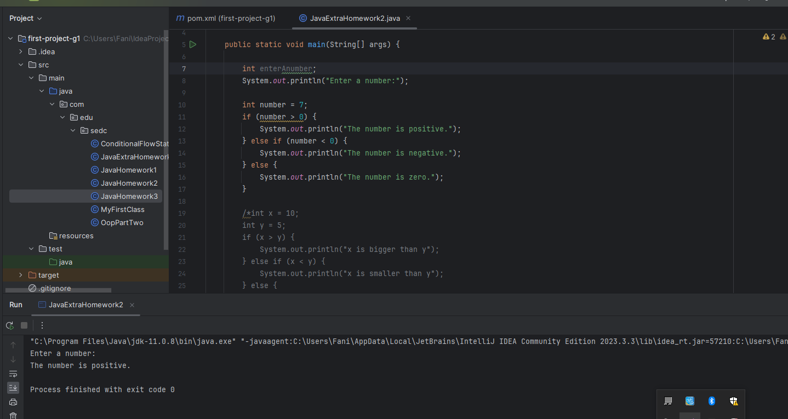

1. Write a program with two int variables, int x and int y, and give each one a value. Depending on their values, print “x is bigger than y”, “x is smaller than y”, or “x and y are the same”. Change the values and run the program a few times to check it works.

‘int x = 10;  
int y = 5;  
if (x > y) {  
 System.*out*.println("x is bigger than y");  
} else if (x < y) {  
 System.*out*.println("x is smaller than y");  
} else {  
 System.*out*.println("x and y are the same");  
}

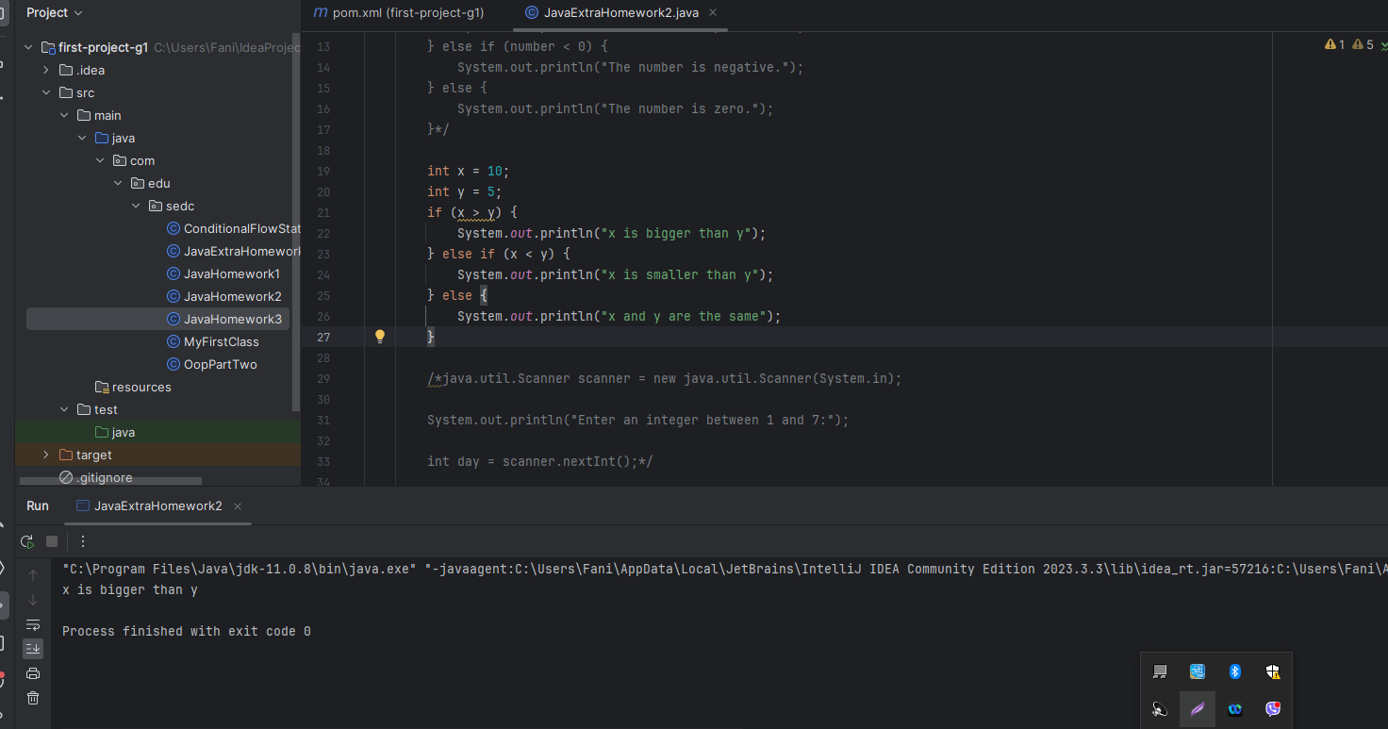

1. Write a Java program that when entering an integer between 1 and 7 displays the name of the weekday.

int day = 7;  
 switch (day) {  
 case 1:  
 System.*out*.println("Monday");  
 break;  
 case 2:  
 System.*out*.println("Tuesday");  
 break;  
 case 3:  
 System.*out*.println("Wednesday");  
 break;  
 case 4:  
 System.*out*.println("Thursday");  
 break;  
 case 5:  
 System.*out*.println("Friday");  
 break;  
 case 6:  
 System.*out*.println("Saturday");  
 break;  
 case 7:  
 System.*out*.println("Sunday");  
 break;  
 default:  
 System.*out*.println("Invalid input");  
 break;  
 }

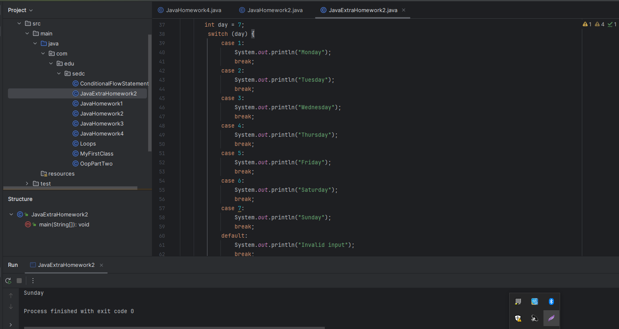

1. Modify the program from Exercise 2 so it also prints the difference between x and y.

int x = 9;  
int y = 3;  
  
if (x > y) {  
 System.*out*.println("x is bigger than y by " + (x - y));  
} else if (x < y) {  
 System.*out*.println("x is smaller than y by " + (y - x));  
} else {  
 System.*out*.println("x and y are the same, so the difference is zero");  
}

